Task 4 : Capital Market Line (CML) and Comparison with the Risky-Only Frontier
1. Tangency Portfolio and CML
Using the 30 industry portfolios and the above risk-free rate, the tangency portfolio was computed for the portfolio that maximises the Sharpe ratio:
$SR=\frac{E(R_{p})-R_{f}}{σ_{p}}$
Metric | Value
Tangency portfolio return | 1.7627% / month
Tangency portfolio volatility | 4.6842% / month
Risk-free rate | 0.3297% / month
Maximum Sharpe ratio | 0.3059
Table 4: Key Results
The slope of the Capital Market Line (CML) is therefore 0.3059, which represents the highest achievable reward-to-risk ratio in the opportunity set.
The tangency portfolio lies exactly on the risky efficient frontier at σ = 4.68%, confirming internal consistency of the optimisation.
2. Comparison: CML vs Risky-Only Efficient Frontier
Metric | Risky Frontier | CML
Frontier shape | Curved (hyperbola) | Straight line
Minimum volatility | 3.24% | 0% (hold RF only)
Return at σ = 0 | Not available | 0.3297%
Tangency return | 1.7627% | 1.7627%
Tangency volatility | 4.6842% | 4.6842%
Maximum Sharpe ratio | 0.3059 | 0.3059
Return at GMV volatility (3.24%) | 1.0132% | 1.3201%
CML advantage at GMV vol | — | +0.3069pp
Return at median vol (4.21%) | 1.6052% | 1.6186%
CML advantage at median vol | — | +0.0134pp
Table 5: Comparison: CML vs Risky-Only Efficient Frontier
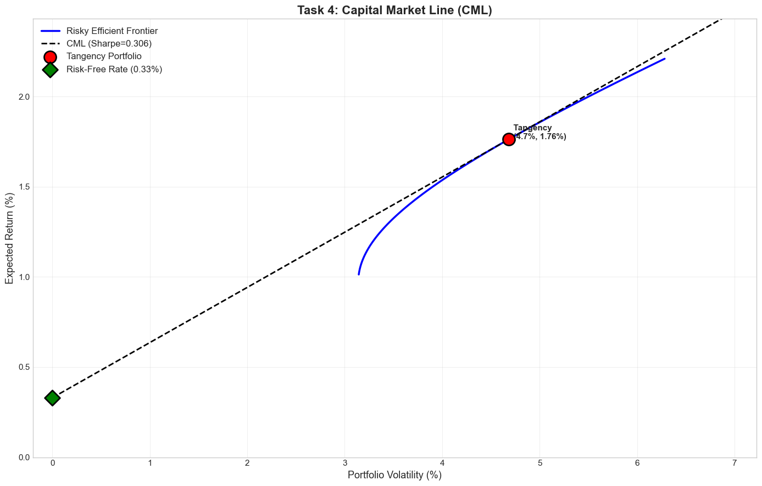
Figure 4: Capital Market Line (CML)
3. Interpretation
Introducing the risk‑free asset effectively straightened the originally curved mean–variance efficient frontier into a linear Capital Market Line (CML), so that all feasible portfolios now lie on combinations of the risk‑free asset and the tangency portfolio rather than along the old hyperbola (Tobin, 1958). This shift raises achievable expected returns at almost every volatility level, since any point on the CML offers a higher Sharpe ratio than portfolios restricted to risky assets only, with particularly large economic gains at low volatility where the return advantage exceeds 30 basis points per month (Sharpe, 1966). In this setting, the tangency portfolio emerges as the unique optimal risky portfolio, and investors differ only in how they mix it with the risk‑free asset, which is exactly what mean–variance theory and Tobin’s separation principle predict (Markowitz, 1959; Tobin, 1958). Overall, the empirical results line up very closely with these theoretical predictions, confirming that access to safe borrowing and lending generates a superior investment opportunity set relative to holding only risky assets (Markowitz, 1959; Tobin, 1958; Sharpe, 1966).
Task 5: Fama–French Factor Models
5.1 Factor Opportunity Sets (Excess Return Framework)
Since Fama French factors are already reported as excess returns (e.g. Mkt - RF), industry returns were also converted by subtracting the risk-free rate to ensure a valid like for like comparison (Fama and French, 1993; Fama and French, 2015). The CML for each set passes through the origin because we are calculating everything in excess return, and its slope equals the Sharpe ratio of the tangency portfolio (Sharpe, 1966)..
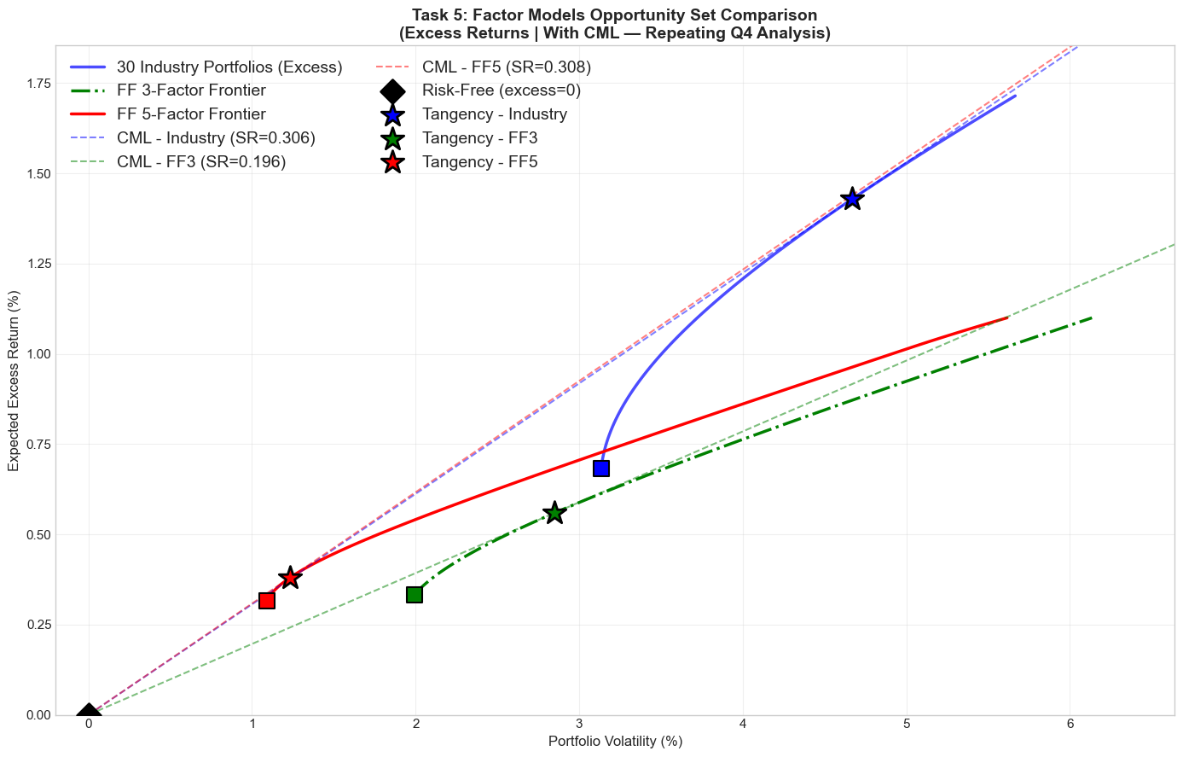
Figure 5:Factor Models Opportunity Set Comparison
Opportunity Set | GMV E[Re]% | GMV Vol% | GMV SR | Tan E[Re]% | Tan Vol% | Tan SR
30 Industries (Excess) | 0.6826 | 3.2279 | 0.2115 | 1.4281 | 4.6667 | 0.3060
FF3 Factors | 0.3329 | 2.0603 | 0.1616 | 0.5592 | 2.8496 | 0.1962
FF5 Factors (2×3) | 0.3153 | 1.3255 | 0.2379 | 0.3797 | 1.2317 | 0.3083
Table 6: Key findings of Factor Models Opportunity Set Comparison
Visually, the FF5 CML appears marginally steeper than the Industry CML, whereas the FF3 line is clearly flatter, signalling a weaker risk–return trade-off in the three-factor case. The improvement in the Sharpe ratio when moving from FF3 to FF5 is sizable, with the slope increasing from 0.1962 to 0.3083, a gain of 0.1121 that is economically meaningful rather than just a rounding artifact. This gain indicates that introducing the RMW along with CMA factors meaningfully improved the spanning set, and, in line with mean variance portfolio theory, expanding the asset universe cannot push the efficient frontier inward, so FF5 cleanly dominates FF3 in Sharpe terms. Interestingly, FF5 also edges out the 30 industry universe, with a slightly higher maximum Sharpe ratio (0.3083 vs 0.3060), although this difference is very small in economic terms and unlikely to drive materially different investment decisions. Overall, factor diversification clearly adds value, but the cross-industry opportunity set is already rich enough that broad industry allocation captures most of the attainable efficiency gains, leaving only a modest incremental benefit for the FF5 specification.​
Comparison to Q4 (Total vs Excess Returns)
In Q4 (total return framework), the Industry tangency Sharpe ratio was: 0.3059 in excess return space: 0.3060 a difference of 0.000102 which is effectively zero.
This confirms the theoretical result (established by Tobin, 1958) that subtracting a constant risk free rate from all returns does not change optimal weights or Sharpe ratios (minor difference due to numerical rounding in the optimizer) (Tobin, 1958; Markowitz, 1952, 1959)..
5.2 Comparison of Factor Model Frontiers
Explaining the Differences
- Dimensionality vs Correlation
Although the 30 industry portfolios give a large menu of assets, they tend to move together because the sectors are highly correlated, so the effective diversification is more limited than the sheer number of assets suggests. In particular, the Fama French factors are deliberately constructed to be close to orthogonal, so each factor captures a different underlying risk dimension. As a result, even with far fewer underlying assets, a portfolio built from these factors can still deliver comparable or sometimes even better diversification than a broad but highly correlated industry set (Elton and Gruber, 1997).
- Long–Short Construction
Industry portfolios are long-only but Fama–French factors are long–short (e.g., SMB = small minus big). This allows them to isolate specific risk premia and generate return patterns that cannot be achieved through simple long-only sector allocation. This structural difference partly explains why FF5 achieves such a strong Sharpe ratio despite having only 5 assets Fama and French, 1993; Fama and French, 2015).
- FF5 Dominates FF3
Adding RMW and CMA increases the spanning dimension from 3 to 5 expanding the asset set cannot make the frontier worse; it can only dominate that too with very little power (Markowitz, 1952, 1959). Empirically, FF5 delivers a materially higher Sharpe ratio than FF3.
- FF5 vs Industry Frontier
Although FF5 has the highest Sharpe ratio (0.3083), the improvement relative to industries (0.3060) is marginal. Industries achieved higher maximum expected returns at higher volatility levels, reflecting greater flexibility at the aggressive end of the frontier. So in practical terms, both opportunity sets are competitive.

Bibliography
- Elton, E.J. and Gruber, M.J. (1997) ‘Modern portfolio theory, 1950 to date’, Journal of Banking & Finance, 21(11–12), pp. 1743–1759.
- Fama, E.F. and French, K.R. (1993) ‘Common risk factors in the returns on stocks and bonds’, Journal of Financial Economics, 33(1), pp. 3–56.
- ​Fama, E.F. and French, K.R. (2015) ‘A five-factor asset pricing model’, Journal of Financial Economics, 116(1), pp. 1–22.
- ​Markowitz, H. (1952) ‘Portfolio selection’, The Journal of Finance, 7(1), pp. 77–91.
- ​Markowitz, H. (1959) Portfolio Selection: Efficient Diversification of Investments. New York: John Wiley & Sons.
- ​Sharpe, W.F. (1966) ‘Mutual fund performance’, The Journal of Business, 39(1), pp. 119–138.
- Tobin, J. (1958) ‘Liquidity preference as behavior towards risk’, The Review of Economic Studies, 25(2), pp. 65–86.

